Stroud District Council

Homelessness Prevention Strategy (Including Rough Sleeping).
2019 – 2024

Introduction
Section 1 of the Homelessness Act 2002 placed a duty on housing authorities to formulate a homelessness strategy. Every five years housing authorities have to carry out a further homelessness review and publish a new strategy (See Appendix 1).
The previous strategy was initially developed with members of the Stroud Homelessness Forum. Since then the Forum has been relaunched as the Stroud Homelessness Working Group and includes external partners and organisations. The previous strategy was reviewed with consultation and feedback from the Working Group in November 2017. This new strategy has also had input from the Working Group which met on 5th September 2018 with the primary aim of identifying trends and particular problems relating to homelessness in the District. This included rough sleeping, financial hardship, older people and support for physical and mental health problems. By consulting with Working Group members the strategy reflects the input of the Homelessness Working Group partners and is based on an understanding of front line services as well as strategic drivers for change, and meeting the challenges brought about by changes in legislation, particularly welfare reform and the Homelessness Reduction Act.
In considering feedback from the Working Group and changes in legislation, the Housing Advice Team will undertake work on establishing targets, responsibilities and time frames for the actions. The strategy is very much a partnership document and, as it reflects the views and aspirations of Working Group members, the intention is that all partners will be involved in its delivery. Implementation of the strategy will be monitored through the Working Group and its success will be reviewed annually.

HOMELESSNESS REVIEW: National and Local Contexts
National Context
The Homeless Reduction Act 2017 is the most significant change to homeless legislation for decades and has strengthened the emphasis on prevention and early intervention. This was a private members bill that passed into legislation having received cross party support and was a response to levels of homelessness which have been consistently increasing since 2010. The graph below shows the number of homeless acceptances each financial year since 2008-9 across England. This clearly demonstrates a 50% increase in homeless acceptances since 2010 from around 40 000 to 60 000.

England: Homeless Acceptances from 2008-9.

As can be seen from the graph below, Stroud had managed to buck the national increase in homelessness through proactive prevention measures, but homeless acceptances have risen over the last few years.

Stroud: Homeless Acceptances from 2008-9.

National Context: Rough Sleeping.
Rough sleeping figures have increased significantly since 2010 with numbers more than doubling, as can be seen from the graph below. The government, in its Rough Sleeping Strategy, has committed to halving rough sleeping by 2022 and ending it by 2027, and have provided funding to Local Authorities for several initiatives including the Rapid Rehousing Pathway and Housing First projects. Official figures for rough sleepers are based on an annual count on a particular night and are either an actual street count or an estimate based on intelligence from various agencies that deal with street homeless people.

England: Rough Sleeping Figures from 2010 to 2018

In comparison, the figures for Stroud have remained fairly stable dropping from 5 to just 1 in 2014 and then being a consistent 2 for three years but then increasing to 4 in 2018.

Local Context: Introduction.
The Homeless Reduction Act has formalised and made statutory the prevention approach to homelessness that Stroud has been taking for some years. The time limit before a homeless duty is triggered has been extended from 28 days to 56 days before actual homelessness. If homelessness is not prevented during this period, there is a further duty to relieve the homelessness for another 56 days. Theses duties apply regardless of intentionality or priority need. The council only has to be satisfied that the applicant is homeless and eligible for assistance. The provisions of the Act have added significantly to both the bureaucracy involved, as well as an increase in caseload. To meet the extra duties, the Housing Advice Team has recruited one full time officer post and one part time business support post, funded by grants from central government. This is approximately a 10% increase in staff resources. However the posts are temporary on fixed term contracts. So far monthly caseloads have increased by an average of more than 200% compared to the same months in the previous year. This has presented a challenging environment for the Housing Advice Team in terms of carrying out the council’s new statutory duties under the Homeless Reduction Act.

Month. | 2017-18 Homeless Applications. | 2018-19 Homeless Applications (Prevention and Relief).
April | 6 | 21 (+250%)
May | 6 | 19 (+217%)
June | 14 | 20 (+43%)
July | 19 | 32 (+68%)
August | 7 | 30 (+328%)
September | 9 | 18 (+100%)
October | 8 | 21 (+163%)
November | 5 | 31 (+520%)
December | 4 | 19 (+375%)
January | 3 | 24 (+700%)
February | 10 | 18 (+80%)
March | 2 | 31 (+1450%)
Total | 93 | 284 (+205%)

Local Context: Homeless Applications and Causes of Homelessness.
Nationally, homeless applications have been increasing since 2008. Stroud had managed to buck the national trend for a few years, but homeless applications have now been increasing consistently since 2014 and have increased significantly this financial year although it is difficult to say how much the increase is due to the extra recording introduced by the Homeless Reduction Act 2017, and how much homelessness has genuinely increased.

The causes of homelessness within the District have remained fairly constant. Relationship breakdown, which includes couples, parental exclusions and domestic abuse are together the single largest cause, although there are indications that loss of an Assured Shorthold Tenancy is becoming an increasing cause.

Changes to local connection criteria for care leavers means that every young person owed leaving care duties by Gloucestershire County Council will have a local connection to all districts in Gloucestershire. The impact of this has yet to be seen, but as much of the county youth provision is based in Stroud it may result in an increase in priority cases that approach the authority.

YEAR | APPLICATIONS | ACCEPTANCES | ACCEPTANCES  APPLICATIONS | INTENTIONAL
2009/10 | 48 | 13 | 27% | 7
2010/11 | 55 | 7 | 13% | 6
2011/12 11/12 | 76 | 26 | 34% | 1
2012/13 | 57 | 19 | 33% | 6
2013/14 | 74 | 17 | 23% | 9
2014/15 | 58 | 12 | 21% | 5
2015/16 | 67 | 20 | 30% | 10
2016/17 | 105 | 40 | 38% | 14
2017/18 | 93 | 39 | 42% | 10
2018/19 | 284 | 9 | 3% | 5

Local Context: Availability of Housing.
Following a downward trend since 2014 in the number of social housing properties becoming available, there was an increase in 2017/18 as the council completed building the first new council houses for decades. However, the numbers have decreased this year compared to the previous year.
Year. | New Social Housing Tenancies.
2014/15 | 648
2015/16 | 471
2016/17 | 441
2017/18 | 478
2018/19 | 439

Since the introduction of the Localism Act 2011, local authorities have been able to discharge homeless duties into the private sector. However, due to the nature of the private sector housing market in Stroud District, and the continuing effects of welfare reform, it has not been possible to discharge a homeless duty into the private sector. The Homelessness (Suitability of Accommodation) Order 2012 has, among other criteria, strict standards for affordability which excludes the private sector rent levels. The freezing of some benefits, particularly Housing Benefit, has placed extra pressure on low income households, and the introduction of Universal Credit has made many landlords, including Registered Providers, more risk averse when it comes to granting tenancies.
In the rental market, average entry level private rents (per month) are well above Local Housing Allowance (LHA) rates (the maximum amount of housing benefit or housing element of Universal Credit that is payable) meaning that even on full housing benefit, top up monies have to be paid to secure a tenancy.

Property size | Local Housing Allowance | Stroud District
1 bed | £398-88 | £525
2 bed | £530-23 | £650
3 bed | £637-56 | £825
4 bed + | £810-94 | £1200

(Median rents for 2017/18 from Valuation Office Agency).

Local Context: Temporary Accommodation.
It is a requirement of Homelessness Strategies under Section 3(1) (b) of the 2002 Act to ensure there is a sufficient supply of temporary accommodation available. In terms of bed and breakfast (B&B) use, the number of households has risen significantly following several years with little change, as has the use of temporary accommodation. Homelessness across the county is on the increase and the bed and breakfasts that provide accommodation are also used by the other Local Authorities. This has led to this accommodation often being full so we have had to use hotel accommodation such as Travelodge and Premier Inn more frequently. As the number of homeless households increases, and it gets more difficult to move them on into long term housing, the average length of time in temporary accommodation has increased. This along with the temporary accommodation that is available being more expensive, has led to a significant increase in costs with the budget this year expected to be overspent by fourfold. The difficulty in sourcing temporary accommodation has also led to families having to be accommodated as far away as Bristol. The lack of suitable family accommodation, other than in Bristol, has also led to an increase in families staying in shared facility accommodation for longer than six weeks, which is against statutory regulations.

Year | 2010/11 | 2011/12 | 2012/13 | 2013/14 | 2014/15 | 2015/16 | 2016/17 | 2017/18 | 2018/19
Households | 38 | 42 | 41 | 40 | 41 | 54 | 61 | 73 | 72

Local Context: Homelessness Prevention

The number of cases successfully completed through the work of the homelessness prevention team has been steadily increasing since 2009 (see figure 1 below). Staff resources have increased to cope with this, up from 1 specialist part time post in 2009 to 2 part time and 1 full time post in 2013 – however, permanent funding was only in place for the original part time post only, the remainder being time limited until March 2015. These posts are now permanent demonstrating corporate support for the effectiveness of homeless prevention. In addition to the specialist advisors, the housing advice officers also undertake prevention work with applicants approaching as homeless or threatened with homelessness. The priority is always to try and secure a person’s current home or assist them in moving to an alternative without the need for temporary accommodation or B&B often with ongoing support provided from the local contracted provider of community based support, currently the organisation known as P3. Preventing homelessness by giving financial help to access private sector tenancies had been dropping due to the widening gap between the Local Housing Allowance and rents. Rents have continued to rise while LHA rates have been frozen. A demand led market which means landlords and lettings agents can be very particular in who they will accept as tenants, and growing unease among private landlords at the implications of Universal Credit have added to the difficulty that households on low incomes face. (This problem has also prevented the council from using the powers given in the Localism Act 2011 to discharge the full homeless duty into private sector accommodation). We have taken action to stabilise the numbers by reassessing affordability limits on the household size, and making further payments to landlords to make the rent levels affordable. Tenants are then encouraged to take steps to increase income through employment, and manage debt through financial advice, so that tenancies are sustainable into the longer term and can be signposted to organisations such as the GEM Project and Citizen’s Advice for help with this. The Housing Advice Team’s focus on preventing homelessness, and willingness to consider all innovative and effective means of preventing homelessness led to Stroud being one of the highest performing councils in the southwest, and the highest performing council in Gloucestershire in preventing and relieving homelessness in 2017/18.

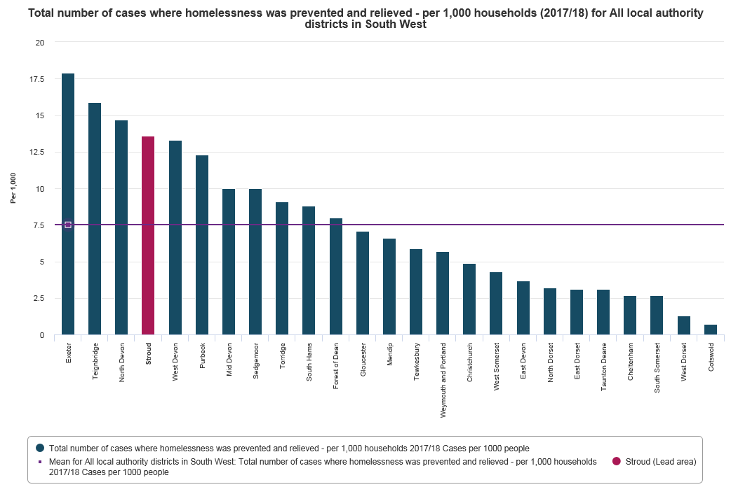

The Housing Advice Team’s success in preventing and relieving homelessness has not come at a high financial cost. The following graph shows compares the council’s spend on homelessness compared to all other councils in the South West and demonstrates the cost effectiveness of the council’s homelessness service.
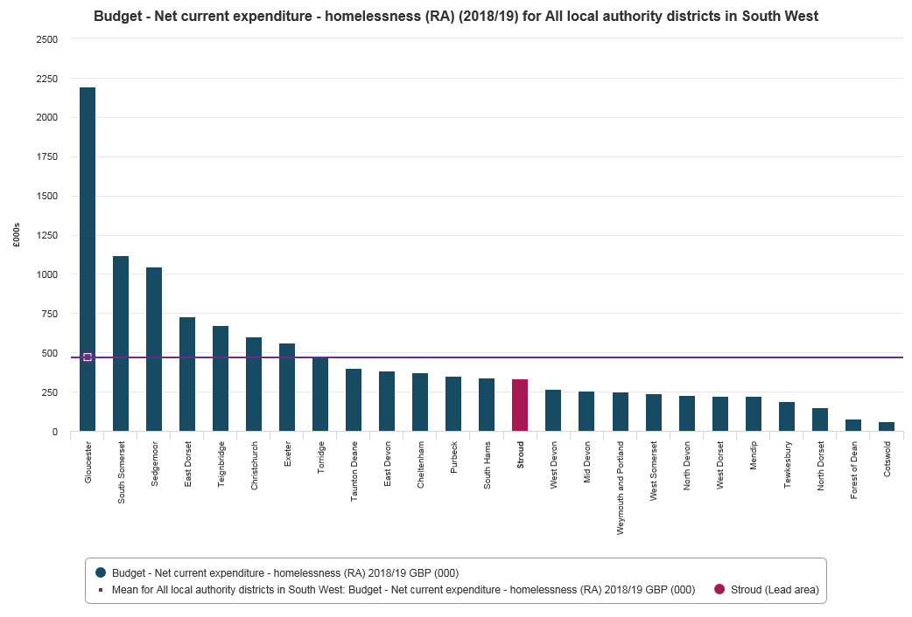

Number of completed homelessness prevention cases 2011/12 to 2017/18 per 1000 households.

Homeless preventions and reliefs have a new statutory reporting mechanism introduced along with the Homeless Reduction Act 2017. Full details have to be recorded onto the countywide IT system (Locata) which then uploads directly onto the governments statutory reporting website, Delta. This means that preventions counted by our partner agencies, both internal and external, need to have their full details entered onto Locata. Previously, we only needed to check that they met the criteria to be counted as prevention, and then provided a figure for the number of preventions. As we do not get enough details of individuals to enter onto Locata, most of the preventions carried out by partner agencies have not been reported. It is therefore expected that the number of preventions as reported to central government will decrease significantly in 2018/19 compared to previous years.
HOMELESS PREVENTION STRATEGY: How we will Achieve Outcomes.
The overall strategic aim is to prevent or relieve homelessness wherever possible. This has then been divided into specific areas identified by Working Group members as local priorities. These include areas such as young people, rough sleeping and domestic abuse. The local priorities are summarised in the table below:
Priority. | Main activities to achieve priority
Young people | - Continue working with partner agencies using tried and tested methods to achieve positive outcomes for young people faced with homelessness.  - To seek to develop an education project for schools with the aim of preventing homelessness
Older people | - Supporting Tenant Services in development of the Older Person’s Housing Strategy  - Continue to develop closer relationships with health and wellbeing services to enable older people to remain in their own homes
Health & Wellbeing | - Continue to develop links with health and wellbeing services to provide suitable housing for those with medical needs
Temporary Accommodation | - To increase the provision of high quality cost effective temporary accommodation to meet increasing demand.
Rough Sleeping | - To support countywide initiatives to meet the government’s targets to reduce and then end rough sleeping.
Domestic Abuse | - To work with voluntary and statutory agencies to enable victims to stay safely in their own homes or move to alternative safe accommodation.

The previous strategy was reviewed annually and changes based on what worked. This Strategy is a combination of what we already do that works well along with new initiatives developed to help prevent homelessness. It will form the basis of the action plan to be formalised following the outcome of consultation on the strategy. This Strategy will also be reviewed annually, but the Action Plan will be a live document, being updated as results are achieved and to reflect any changes in legislation.

Prevention and Relief: Methods.

The range of work carried out by the homelessness prevention team has also broadened over the last few years and we now offer:

- Grants for deposits and agency fees to access private rented homes
- Counselling for young people and their families
- Counselling for couples
- Sanctuary scheme for victims of domestic abuse to enable them to remain in their homes safely
- Double deposit payments for landlords in lieu of guarantors
- Support for people leaving hospital after crisis to secure suitable accommodation if they cannot go back to their previous home
- Support to access Discretionary Housing Payments and the financing of a specialist debt advice worker in Stroud Citizens Advice
- Provision of rent guarantee insurance
- Payment of rent arrears to secure a tenancy at risk (where extenuating circumstances have resulted in arrears)
- Referrals to specialist community based housing support through Supporting People contracted provider P3
- Renegotiation fee to bring rents in line with Local Housing Allowance rates
- Paying for other solutions to tenancy breakdown e.g. clearing garden/property; sound insulation etc.
- Setting up direct payment of Housing Benefit/Universal Credit
- Training to support organisations to ensure accurate advice is given at the earliest opportunity and that the organisations are aware of the help available from the Housing Advice Team
- Outreach advice sessions at partner agency locations
- Collaborating on a countywide basis to bid for central government funding to provide prevention and relief services
This list is not exhaustive - our approach to homelessness prevention is to do whatever is needed to secure and maintain a tenancy and there is the flexibility to respond creatively.

Prevention and Relief: Reporting.

If we fail to report our actual level of prevention and relief it may affect future funding and the reputation of the council. Due to the difficulties detailed we aim to achieve the following targets:

- Work with partner agencies to devise a system of obtaining sufficient information from them to be able to input each case on Locata so that it can be uploaded onto the governments Delta website as a prevention or relief.
- To ensure data sharing arrangements are robust and GDPR compliant.
- To regularly monitor the data sharing arrangement to ensure it is working smoothly and minimising any extra workloads.

Prevention and Relief: Affordability.

In a climate of reducing levels of affordable private rented sector accommodation we will:

- Increase the use of landlord payments to reduce rents to affordable amounts for 12 months.
- Formalise the process for referrals to money advice and agencies which help to increase employment prospects in order to make tenancies sustainable long term.
- Seek ways to continue this financial support following the enactment of the Tenant Fees Bill in June this year.
- Continue to provide support for deposits and fees wherever possible.
- Support the countywide bid for funding from the government’s Private Rented Sector Access Fund to be able to advertise suitable private rented properties through HomeseekerPlus and increase the number of households we can help to access the private sector.
- Continue to pay arrears in exceptional circumstances where it is likely to lead to a sustainable tenancy.
- Grant funding to P3 who can use the grant to pay rent in advance.
.

Young People.

- There is a single point of access for supported housing for young people via the START 16+ process, and to Kingfishers, which is supported housing for young people with learning disabilities. The START 16+ meeting is attended by the youth accommodation providers in the District and is designed to ensure young people are offered a placement in the most appropriate accommodation for their needs.
- County reconnection policy ensures people can return to their community and retain their links with social, education and employment networks

- Counselling service for young people and their families to enable them to resolve their conflict and remain in secure accommodation with a managed move to independent living

- Funding provided towards provision of countywide volunteer hosting service (Nightstop) that provides emergency temporary accommodation and support for a 16-25 year old until homelessness is resolved

- Funding provided towards provision of two units of “crashpad” style accommodation through the START 16+ process. Provision of these services is to help ensure the authority does not place people under 18 into bed and breakfast type accommodation. Government guidance is that this type of accommodation is not suitable.
- Development of varied opportunities through social enterprise
- Stroud Beresford Group (who also provide the women’s refuge) provide support to young people including domestic abuse support and awareness raising workshops. The Housing Advice Team provides a grant to the Beresford Group to help them maintain their services.
- Grant provided to youth service to provide starter pack boxes for young people which include bedding and basic toiletries.

- To explore the possibility of a weekly housing allowance for families to avoid parental evictions due to hardship.
- To work with and support partner agencies in tenancy training for young people.

Older People.

The council is currently reviewing and updating its stock of sheltered housing for people over 60. The Housing Advice Team will support this by:
- Housing Advice Manager to provide input by attending meetings of the Vision and Strategy group, part of the Sheltered Housing Modernisation Project.
- Provide statistical evidence to guide levels of demand and suitability of accommodation for older people
Further measures:
- To work with Occupational Therapists, other health specialists and housing providers to ensure Disabled Facility Grants are used effectively to enable people to remain in their own homes
- Creating a web page giving general advice and housing options for older people.

Increasing Housing Supply.

Stroud District Council is approaching the end of a £19 million pound project to build more than 235 new council homes, the first for decades. The government has now relaxed regulation to allow councils to borrow more to build new council homes so a further building project is being developed. The Housing Advice Manager was involved in the initial project and will:
- Attend future meetings of the project to influence the level and types of properties being built to ensure they match demand.
- Provide data from the housing register to inform the above.
- Will also attend development meetings with Registered Providers to influence types and locations for new build to ensure they meet highest demand.
- Provide a contribution to the Housing Strategy.

Health and Wellbeing.

Housing and homelessness are strongly linked to health and wellbeing and much of what we already do and plan to do in the future will be covered under other headings such as rough sleeping and domestic abuse.
- Member of Housing Advice Team attends Health and Wellbeing partnership meetings.
- Agreed move-on priority for tenants of Rethink Mental Illness accommodation. They have 13 units of independent supported housing at Eagle Mill Close in Stroud. By agreeing move-on priority it ensures the properties are used for those with the greatest need.
- Advertising Housing Advice services in Community Care Guide magazine – distributed to GP surgeries and health centres throughout the District.
- Developing and strengthening links with health and wellbeing agencies such as community partners (social prescribers), practice nurses, health visitors and mental health teams. We have also invited them to training sessions which help build good relationships as well as helping to ensure accurate advice is given at the earliest opportunity.
- Implementation of the Homeless time to Heal project between Elim Housing and both Gloucester Royal Hospital and Wotton Lawn Hospital to identify single people who are homeless and about to be discharged and ensure they have appropriate accommodation and support.

- Promoting the Duty to Refer brought in with the Homeless Reduction Act 2017 to health and wellbeing agencies so those at risk of homelessness are identified and contacted at the earliest opportunity.
- Grant funding to the Furniture Bank to ensure homeless households have access to basic furniture when rehoused.
- Developing and strengthening links with Change, Grow, Live, the countywide organisation providing support to people with drug and alcohol problems.
- Grant funding to Ebenezer, an organisation that provides accommodation and support in gaining employment for people with addiction problems.
- Grant funding to the MARAH Trust, a local charity that provides support and practical help (food, transport to other agencies etc.).

Temporary Accommodation.

Due to increasing demand, and lengthier stays in temporary accommodation, we will improve the quantity and quality of available temporary accommodation, as well as sourcing more accommodation within the District. We will also aim to eliminate the use of bed and breakfast type accommodation for families for longer than six weeks, and reduce or stabilise overall costs.

- Continue to source high quality temporary accommodation through private sector companies in or close to Stroud District
- To continue to work with landlords of currently used accommodation to improve the quality of that accommodation by conducting regular visits.
- Monitor the use of a council property that has recently been converted for use as temporary accommodation, with the aim of utilising further properties for use, if successful.
- Procure through build or purchase a building within the District to convert into high quality bespoke temporary accommodation using funding agreed by Strategy and Resources Committee.
- To procure management of this property from a Registered Provider so that stays for families are not limited to six weeks.

Rough Sleeping.

Although rough sleeping has historically been at relatively low levels within the District, the latest official annual estimate found there to be 4 persons sleeping rough, compared to 2 in the previous three years. There has also been an increase in the visibility of rough sleeping with street begging on the increase, although there is evidence that not all of the people begging are homeless. This has combined with more media attention on rough sleeping to increase the pressures to address the problem. Rough sleepers tend to be drawn to major settlements where there are more services, and within the county it is Gloucester that has by far the highest number. Many of the initiatives and services to help rough sleepers to move off of the streets are commissioned on a countywide basis. This not only helps with economies of scale, but this type of partnership working is also encouraged by central government for funding bids.

- Joint commissioning of countywide outreach service provided by P3. Anyone rough sleeping can be reported to P3 by members of the public via Streetlink. P3 will then meet the person and assist them into accommodation where their needs can be assessed.
- Successful countywide bid for £1.27 million for SIB (Social Impact Bond) project. The purpose is to help the most chaotic and entrenched rough sleepers off of the streets using the Housing First model. (There are 127 people that have been identified across the county that fit this category). This is where support services for such things as mental health problems, addiction problems is provided after the person is moved into accommodation, and has had successful results where it has been trialled.
- Provision of accommodation for the SIB project through two of the council’s properties.
- Supporting countywide bid for funding for Rapid Rehousing Pathway (part of the government’s Rough Sleeping Strategy). This is to set up direct access accommodation for people who are already rough sleeping or at risk of rough sleeping. They are then quickly assessed in line with the Homeless Reduction Act 2017, offered appropriate support and rapidly helped into a settled home.
- Participating in countywide SWEP (Severe Weather Emergency Protocol). The Housing Advice Manager monitors weather forecasts through the meteorological office website. Where forecasts are predicted to meet SWEP criteria, all relevant organisations are contacted and accommodation is made available for all rough sleepers. This is a humanitarian response to severe weather and is regardless of priority need or intentionality, and includes those who are not eligible for housing assistance due to their immigration status.
- Grant funding for MARAH Trust who provide practical help and support for homeless persons.

Domestic Abuse.

This is another area which has a high media profile and is receiving government support, both in changes in legislation, and grant funding for successful bids from relevant organisations. Stroud District is the only local authority area within the county that still has its own women’s refuge run by the Beresford Group, a registered charity. GDASS (Gloucestershire Domestic Abuse Support Service) is the countywide organisation providing support and advice to anyone suffering from domestic abuse. They were successful in a bid, supported by Stroud District Council, for central government funding to provide Places of Safety, properties provided by Registered Providers across the county as temporary accommodation for all victims of domestic abuse.

- To continue funding target hardening and sanctuary scheme work to enable victims to remain in their own home safely.
- To continue partnership working with GDASS to ensure households in Places of Safety secure appropriate accommodation.
- To provide grant funding to the Beresford Group to help their work with victims of domestic abuse.
- All Housing Advice team receive training in domestic abuse.
- To provide grant funding to the Furniture Bank in order to subsidise furniture for families moving on from Stroud Womens Refuge.
- Move on priority and local connection is given on HomeseekerPlus to women from the refuge once it is confirmed they are ready for independent living. This avoids the need for a homeless application and the intrusion
- Applicants with rent arrears are suspended on HomeseekerPlus until the arrears are cleared or a payment plan has been kept to for an agreed period. The Housing Advice Manager can make exceptions to this policy, taking into account personal circumstances as well as the level of the debt and arrears history. An exception will always be agreed where arrears are confirmed to result from coercive, controlling or financial abuse.

