

**STROUD DISTRICT COUNCIL (SDC)**

**DRAFT ANTI-SOCIAL BEHAVIOUR**

**POLICY**

**2024 - 2027**

1. **Contents**

Relevant Key Legislation, procedures, guidance, and partners can be found in the appendices at the end of this document.

1. Contents Page 2
2. Introduction Page 3
3. Anti-Social Behaviour Mission Statement Page 4
4. Stroud District Community Safety Partnership (SDCSP) Page 4
5. Serious Violence Statutory Duty Page 4
6. How to Report Anti-Social Behaviour (ASB) Page 4
7. SDC Approach to ASB “The Framework” Page 5
8. Prevention and Community Involvement Page 6
9. Early Identification Page 7
10. Supportive Intervention Page 7
11. Enforcement Page 8
12. Who deals with ASB reports to the Council Page 8
13. SOLACE Page 9
14. Counter Fraud Enforcement Team Page 10
15. Training Page 10
16. Understanding the issue (What is ASB)? Page 11
17. Definitions/Types of ASB Page 12
18. What the Council will not investigate. Page 12
19. Flow chart for dealing with ASB complaints Page 14
20. ASB Case review (formerly known as community trigger Page 15
21. Communication & information sharing between SDC Depts Page 15
22. Performance Monitoring and Reporting Progress Page 15
23. Appendices & Glossary of Terms Page 16-23
24. Document History Page 24-25

1. **Introduction**

Stroud district is a unique place in which to live, work, visit and relax. All residents, visitors, tourists, and businesses throughout the district have the right to enjoy the area, to live peacefully in their homes and neighbourhoods, to feel safe and secure and should not suffer from anti-social behaviour, nuisance, or harassment.

Anti-social behaviour (ASB) in all its forms is one of the most important challenges that all Local Authorities face, Stroud District Council (SDC) is no different. The Stroud district has a great deal to offer: a rich cultural heritage and diversity of population, affordable housing, good schools, a sound local economy and a geographical position that provides excellent links around the country, by motorways, and rail links.

Antisocial behaviour is defined as 'behaviour by a person which causes, or is likely to cause, harassment, alarm, or distress to persons not of the same household as the person

However, ASB (both actual and perceived) is the single factor that significantly undermines all these positive features of the district. Residents in urban, rural, or semi-rural areas and people who live or work here, may experience different types and levels of ASB but ultimately, whether it is rowdy or drunken behaviour, irresponsible behaviour such as littering or lack of respect for local communities and the environment, the effect is negative and has a considerable impact on quality of life which impacts on a person’s wellbeing and mental health.

This policy includes some basics: clarifying what falls within the definition of ASB and what does not. Some activities are frequently reported to the Council as ASB, for example, drug dealing and drug use on the street, which are criminal acts not ASB and issues that the Council does not have the powers to address – these are matters for the Police and law enforcement agencies. The policy also demonstrates that our commitment is to address ASB in all its forms and at all levels. This is in recognition of our understanding that some forms of ASB, sometimes seen as low-level and especially when persistent, can have a devastating impact on its victims.

This document outlines our approach as a District Council to prevent, identify, support, and enforce ASB. More importantly this document illustrates how alleged victims can report cases directly to us and what to expect from us when making these reports putting the victim at the centre of our approach.

This policy does not sit in isolation but is intended to sit alongside other publications such as the ‘Stroud District Community Safety Partnership(SDCSP) Plan 2023 -2026 and ‘The Council Plan 2021 - 2026 both of which have a commitment to improve Stroud District and make it a safe place to live, work and visit.

This policy sets out the guiding principles of how we will work together to identify those issues that have the most impact on residents and visitors within the Stroud district, along with how we investigate and resolve reports of ASB and highlight the values and beliefs of the partnership to serve as a guideline for operational decision making.

1. **Anti-Social Behaviour Mission Statement**

**3.1** As a council it is our mission to adopt a victim centred approachand take all complaints of anti-social behaviour seriously, treat victims fairly and with dignity, carrying out investigations, signpost victims to appropriate agencies and organisations for support should they need it.

**3.2** We will ensure the victims voice is heard and this will play a key role in the continuous development of this policy and future process to ensure we provide an excellent service that encourages reporting, supports, and effectively communicates with victims.

**4. Stroud District Community Safety Partnership (SDCSP)**

**4.1 T**he Crime & Disorder Act 1998 Section 17 (**See Appendix 6**) imposes a statutory duty on all Local Authorities to do all they can to prevent crime, fear of crime and anti-social behaviour within their areas.

* 1. SDCSP has a three-year Community safety plan with five priorities including Priority one to address Anti-Social Behaviour in all its forms. (**See Appendix 3)**

1. **Serious Violence Statutory Duty (as amended Section 17 Crime & Disorder Act 1998) (See Appendix 6)**
   1. The Duty is intended to ensure relevant services including SDC work together to share information and collaborate on interventions to prevent and reduce serious crimes within their local communities.
   2. The link between anti-social behaviour and serious violence is a complex and multifaceted issue that requires a holistic and coordinated response. By addressing the underlying causes of anti-social behaviour and violence, communities can create a safer and more inclusive environment for all residents.
2. **How to Report Anti-Social Behaviour (ASB)**
   1. SDC encourage all residents of and visitors to the district to report issues they perceive to be ASB to the Council by using one of the contact methods below paragraph 6.5

**6.2** If you are an owner/occupier of a premises or a visitor within the Stroud district and wish to report anti-social behaviour, we will aim to respond to your complaint within five working days depending on what sort of complaint is made it will be sign posted to the relevant service and/or organisation for their attention and any action.

**6.3** Housing Providers throughout the district will have their own ASB Policies & Procedures, the first point of contact if you are in housing provider accommodation is to contact them direct to report ASB.

**6.4** If you are a Stroud District Council Tenant, please see Stroud District Council Tennant Services ASB Policy (**See** **Appendix 1)**

If you are experiencing anti-social behaviour and have not been able to resolve the situation, you should contact your landlord first for help and advice. Depending on the type and intensity of the anti-social behaviour you may be asked to also report the incident to the police or your local authority.

**6.5** You can report ASB to **Stroud District Council** by

1. Stroud District Council Website Online reporting:-

<https://www.stroud.gov.uk/report-it/antisocial-behaviour/>

for SDC tenants <https://www.sstroud.gov.ukhousing/im-an-existing-tennant>

1. Stroud District Council Telephone Contact:- **01453 766 321**
2. Text : - You must start your message with the word **'COUNCIL'** otherwise it will not be received - Text: 07851 729229. Please include your name and address.
3. In person at our offices Stroud District Council, Ebley Mill, Ebley Wharf, Stroud, GL5 4UB
4. Directly to a council officer who is working in your area who can support you to complete the online reporting process.
5. You can also report ASB to Gloucestershire Police online <https://www.gloucestershire.police.uk/contact/af/contact-us/>

**6.6** Any Anti-Social Behaviour which includes criminal acts should be reported to Gloucestershire Police on 101 or call 999 if you are reporting a crime that is in progress or if someone is in immediate danger.

**7** **SDC approaches to responding to ASB.**

**7.1** There are a range of tools available to SDC to use in response to reports of antisocial behaviour. The image below shows a pyramid of hierarchy. This is the model that SDC will use, focusing on “Prevention and Asset Based Community Development (ABCD) or community involvement in the first instance and using our enforcement powers as a last resort.

**7.2** Asset Based Community Development (ABCD) uses the skills, experience, talents and enthusiasm of local individuals, communities to strengthen the community they live in. It is based on the idea that strong communities are built by recognising, celebrating and harnessing the ‘community assets’ that are already there.

**7.3** Each case is assessed based upon severity and impact to the victim and wider community against the resources available to us. This means that lower levels of ASB may not be acted upon as a single issue but is monitored for frequency and impact before action is taken. If this is the case, we will communicate our action to the complainant.

**7.4** **The Framework**

**8. Prevention and ABCD, Community Involvement**

Ideally, we want to stop ASB before it happens: -

A systematic approach to prevention will include the following:

* Collaborating with residents in areas where ASB is a concern to bring them together through asset-based community development (ABCD) initiatives to create a sense of ownership and pride in their local neighbourhoods.
* Considering preventative measures when future strategies are being developed for example the Stroud district Youth Strategy.
* Educating people and raising awareness of the forms and consequences of engaging in ASB, making clear what is acceptable and what is not acceptable behaviour and promoting respect for others and environments.
* Taking into consideration to design-out opportunities for ASB through minor changes to the physical environment and to ensure that new developments consider features to prevent ASB e.g., adequate lighting, CCTV.
* Providing a visible and uniformed presence (and increasing visibility through joint work with partner agencies) in areas where ASB is more prevalent.
* Ensuring that children and young people have access to facilities and activities that will encourage them to spend their leisure time constructively.
* Collaborating with schools/education providers to make clear that bullying and ASB is unacceptable by encouraging citizenship and social responsibility.
* Collaborating with SDC Members, community, and faith leaders to address ASB in SDC Wards where it is most prevalent.

**9** **Early Identification**

**9.1** When ASB does occur, our objective is to act quickly with informal interventions to ‘nip it in the bud,’ to minimise the impact and prevent the problem from escalating.

This work could include:

* Providing advice and support to the victim, taking account of any vulnerabilities and signposting to other agencies and services as appropriate.
* Considering the option of using restorative justice or facilitating mediation between the offender(s) and victim(s). SDC is a Restorative Gloucestershire organisation signatory.
* Developing action plans to tackle the issues identified.
* Verbal Warning
* Issuing initial warning letters to identified offenders.
* Using Acceptable Behaviour Agreements (ABAs).
* Encouraging young people as at risk of or having begun to engage in ASB to take advantage of diversionary activities available.
* Issuing Community Protection Warnings.

**10** **Supportive Intervention**

**10.1** SDC approach recognises that some trauma informed perpetrators may have certain personal characteristics or support needs that are influencing their behaviour which may also make them vulnerable. SDC and partner agencies have safeguarding responsibilities that apply equally to victims and to those who may be causing ASB inadvertently due to complex needs. When initial investigation into complaints of ASB establish this to be the case, concerted efforts will be made to encourage the individual/s concerned to get the help and assistance they need to modify their behaviour. Supportive intervention may include (with consent where appropriate):

* Referral to local drug and alcohol treatment service providers.
* Intervention provided by the Homelessness groups.
* Community Resolution (Police only).
* Direct referrals to statutory agencies and services e.g., Gloucestershire County Council’s Social Services, Mental Health Services, Gloucestershire Police.
* Working with Gloucestershire County Council’s Early Help to support families in which there are children/young people who are perpetrating ASB.
* Where ASB is related to domestic abuse, ensuring that victims are made aware of and encouraged to access specialist domestic abuse support services available locally.

**10.2** In cases where a safeguarding issue with a child or adult is considered officers **must** refer to SDC Safeguarding policy and procedures.



**11** **Enforcement**

**11.1** In many cases, enforcement will be a last resort and SDC will take all necessary steps with partner agencies to ensure that enforcement action is justified and proportionate to the type of ASB that has occurred. Formal action may include:

• Use of legislative powers e.g., Injunction, Community Protection Notice, Closure

Order.

• Exercising sanctions against those responsible for licensed premises.

• Issuing Fixed Penalty Notices or prosecuting those identified as responsible for

environmental crimes that also fall with the criteria of ASB e.g., littering, fly tipping.

• Use of legislative powers under the Environmental Protection Act 1990 to address

ASB linked to noise nuisance e.g., Noise Abatement Notice.

• Taking appropriate action against private property owners who fail to meet their

responsibilities in maintaining their properties and managing their tenants which

then results in ASB to the wider community.

**11.2** Anti-Social behaviour enforcement is a critical aspect of maintaining safer communities. To effectively address anti-social behaviour collaboration with partners is essential, SDC will adopt a multi-agency approach when dealing with perpetrators of ASB using relevant legislation.

**12**. **Who deals with ASB reports to the Council**

**12.1** Any ASB report received by SDC by whatever means will be properly recorded and allocated to the relevant service area for investigation. SDC has a cross-service policy when dealing with ASB this means that a complaint is received by one service who will take the lead role, but collaborate with officers from other services to find a solution.

**12.2** Various departments within SDC deal with ASB namely: -

**12.2.1** **Community Services**

* Fly tipping
* Fly Posting
* Abandoned Vehicles
* Littering
* Graffiti
* Dog fouling
* Intimidating behaviour
* Waste management
* Hate crime/incident
* Criminal Damage
* Noise
* Parking
* Overgrown hedges

**12.2.2** **Environmental Health**

* Light Pollution
* Animal welfare
* Dog Fouling
* Fly tipping
* Noise
* Contaminated land
* Smoke/Bonfires
* Control of smoking in enclosed spaces
* Smells

**12.2.3** **SDC Tenant Services (See Appendix 1)**

* Threat to life.
* Assault.
* Hate crime.
* Safeguarding matters including child neglect.
* Drug dealing and or substance misuse.
* Graffiti and other forms of vandalism and damage (unless offensive, racist, or identifying individuals in which case action is taken to remove within 4 hours

following notification).

* Animal nuisance (fouling, pets out of control).
* Fly tipping (unless a health hazard then this would be escalated for action as soon
* as possible).
* General noise nuisance (if significant intervention from Health and Wellbeing colleagues may be required).

**12.2.4** All SDC Services will work together to address more complex ASB issues.

**13** **SOLACE**

**13.1****.** Solace is a partnership between SDC and Gloucestershire Constabulary. The multi-agency team work together with communities to prevent, investigate, and tackle medium and high level anti-social behaviour (ASB). The aim is to reduce repeat incidents and victims of ASB by providing a consistent partnership approach between the Constabulary and local authority alongside support agencies and other partners.

**13.2** Solace will provide ASB investigation, resolution and support services to all owner-occupier and private residents who reside in the rural & urban areas of Stroud district, on behalf of the SDC. They also supply some support and guidance to social landlords and housing associations where required although not in the first instance. Issues relating to ASB within public and open spaces can also fall within the remit of Solace in accordance with the statutory duty placed upon local authorities.

**13.3** SDC have a case worker who works directly with SOLACE and the Police.

**13.4** Should information be received that a particular area within the district is suffering ongoing ASB, a targeted and direct approach will be considered to address the issue(s) and provide the community with support and reassurance by working with all partners and residents.

**14 Counter Fraud Enforcement Unit (CFEU)**

**14.1** Stroud District Council joined the Counter Fraud and Enforcement Unit (CFEU) partnership in April 2024. The partnership is a shared service between a number of Local Authorities, including five of the Gloucestershire district/borough authorities.

**14.2** The CFEU supports SDC officers with enforcement activity which includes lower levels of ASB such as fly tipping, littering or noise nuisance. The team offer support with criminal investigation processes, training, and court attendance as required.

**15** **Training**

**15.1** All SDC officers who are responsible for dealing with and investigating ASB will be trained at a level commensurate to their role and expertise by the Counter Fraud Enforcement Team and other agencies to enable them to perform their duties fairly and comprehensively. All officers must have delegated authority to carry out their role issued by an appropriate Head of Service.

The training will include.

* Knowledge of relevant legislation and powers
* Evidence Gathering
* Statement taking/writing.
* PACE Interviewing witnesses and alleged offenders.
* Giving Evidence
* Conflict Resolution
* Restorative Practice

**15.2** All staff who are responsible for ASB will undergo ASB enforcement training as part of their induction., Existing staff will have regular refresher training to keep up with relevant legislation changes.

**16** **Understanding the issue (What is ASB)?**

**16.1** One of the challenges in defining ASB is that behaviour deemed by one person to be antisocial, distressing, intimidating, or causing a nuisance, may be perceived quite differently by another. Additionally, an individual’s circumstances may mean that the impact of behaviour is exacerbated e.g., where they have experienced similar problems in the past, have been a victim of crime or have personal characteristics that may increase their vulnerability.

**16.2** Whilst legislative definitions can be used as a rule of thumb and for evidence building, it is important that individual cases circumstances be considered.

**16.3** This policy uses these categories to help us define and monitor incidents of ASB that occur in the district with the issues falling under each of these in the infographic below.

**17** **Definitions**

**The Crime and Disorder Act 1998 defines ASB as an act which ‘causes or is likely to cause ‘harassment, alarm or distress’ to one or more persons not in the same household’.**

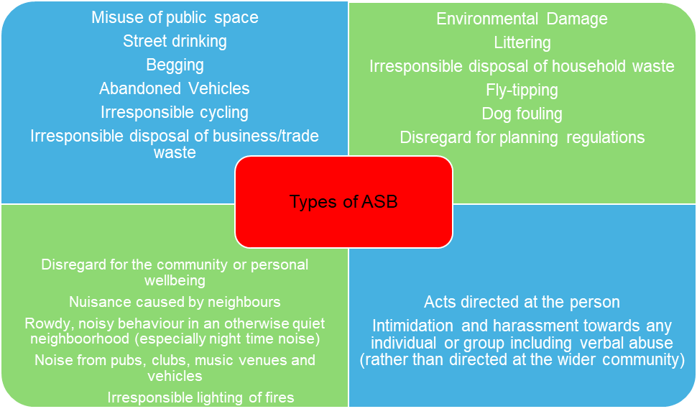

**17.1** The above infographic is not an exhaustive list; any behaviour that is regarded as a nuisance that has occurred repeatedly may be considered as ASB. It is important that reported incidents are assessed individually taking account of the impact on the victim. In some cases, the form of ASB or the circumstances in which it is perpetrated may also constitute a criminal offence.

**17.2** There are several types of ASB which can impact on the lives of people and communities, for more information please (**See Appendix 2)**

**18** **What the Council will not investigate.**

SDC is committed to developing and supporting cohesive communities across the district, but this commitment must run alongside a reasonable level of tolerance between neighbours and others within neighbourhoods. Residents are encouraged, where possible, to try to resolve their disputes themselves without the need for the SDC to become involved. Officers will seek to make a fair evaluation on whether complaints reported are reasonable and determine whether they constitute alleged ASB.

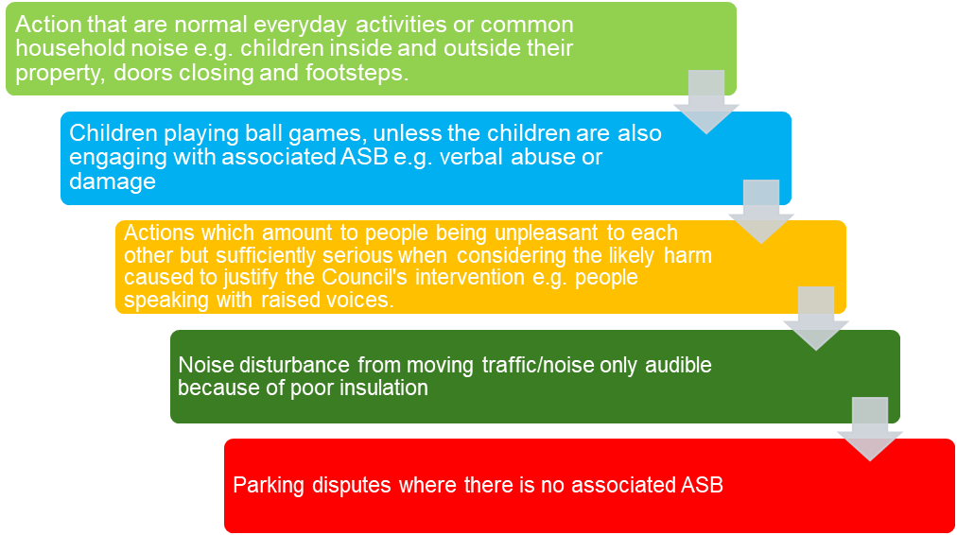

**18.1** Criminal Acts such as drug dealing and public order offences etc are dealt with by Gloucestershire Police and/or other law enforcement agencies and should be reported direct to them using 999 in case of an emergency or 101 or Crimestoppers 0800 555 111

**19. FLOW CHART FOR DEALING WITH ASB COMPLAINTS**

Whilst our aim is to deal with all ASB cases we do have to assess each case and make decisions based on the impact and severity to the victim and wider community against the resources available to us. This means that lower levels of ASB may not be acted upon a single issue but is monitored to create a picture of frequency and impact before action is taken. In these cases, we will communicate the outcome of our action to the complainant.

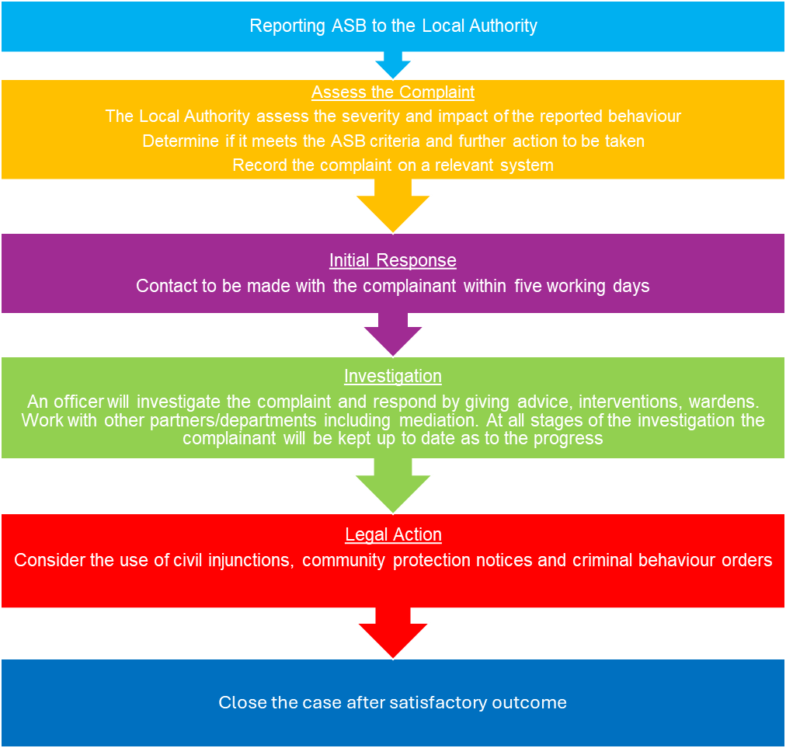

**20. Anti-Social Behaviour Case Review**

**20.1** An ASB Case Review (formerly known as a Community Trigger) is a statutory requirement (ASB, Crime & Policing Act 2014) designed to provide an opportunity for victims of ASB to have their case independently reviewed. The Council has agreed to transfer the responsibility for the management of a ASB case review to Restorative Gloucestershire.

**20.2** Victims can activate the ASB Case Review and instigate the Councils complaints procedure simultaneously.

**20.3** The ASB Case Review process is outlined in detail within the Gloucestershire Restorative Justice web site at [www.restorativegloucestershire.co.uk](http://www.restorativegloucestershire.co.uk)

To instigate the ASB Case Review, the complainant must:

* Have made three reports of ASB within 6 months.
* Have made five reports of ASB, involving the same location, culprit, or problem from more than one individual or group of individuals within 6 months.
* Made an application of ASB within a reasonable time- allowing for time for action to have been taken.

**20.4** The ASB Case Review, is an audit of the ASB case to make sure SDC has followed their policies and put forward the reasonable resolutions to resolve the ASB. This is an independent review.

**21** **Communication and information sharing between SDC Departments**

**21.1** Responding effectively to reports of ASB from the point of contact through to the management of a case, relies on effective communication and information sharing between the services and teams involved. Lack of communication can lead to an unnecessary duplication of effort but more importantly, can mean that a vulnerable victim of ASB may not be provided with the appropriate support and advice that they need.

**21.2** Information can be shared under S115 Crime and Disorder Act 1998 (**See** **Appendix 6**)

**21.3** Information sharing between organisations within Gloucestershire and part of the ASB group can use the below Gloucestershire County Council Information sharing agreement. (**See** **Appendix 3)**

**22**. **Performance Monitoring and Reporting Progress**

**22.1** The ASB Policy will be monitored as part of the Council Plan. Quarterly meetings are held by Stroud District Community Safety Partnership with a particular ASB sub-group set up to address issues that arise and discuss work that has been done by internal and external partners to resolve issues and review DATA of all forms of ASB.

**22.2** SDC is committed to delivering a high quality anti-social behaviour service. Our aim is to continuously improve the way we work and to acknowledge, and learn from, the occasions when the service fails to meet expectations.

**22.3** How we deal with ASB in the community is also monitored against the priorities laid out in the Stroud District Community Safety Plan 2023 – 2026 Priority One (1) (**See Appendix 3)**

**22.4** We report on our performance against these priorities.

Appendices

**Appendix 1**

**Stroud District Council Tenant Services Anti-Social Behaviour Policy**

<https://www.stroud.gov.uk/media/ebsou5ur/anti-social-behaviour-policy-2021.pdf>

**Appendix 2**

Types of Anti-Social Behaviour

**Abandoned Vehicle**:

This covers vehicles that appear to have been left by their owner, rather than stolen and abandoned. It includes scrap or ‘end of life’ vehicles and those damaged at the scene of a road traffic collision that have been abandoned and are not awaiting recovery. This does not cover vehicles that are taxed and MOT’d as they are not deemed to be abandoned.

**Vehicle nuisance or inappropriate use**:

This relates to vehicles being used in acts such as street cruising (driving up and down the street causing annoyance and bothering other road users), vehicle convoys and riding or driving on land other than a road. It also covers the misuse of go-peds, motorised skateboards and electric-propelled cycles, and the unlicensed dealing of vehicles where a person has two or more vehicles on the same road within five hundred metres of each other.

**Rowdy or inconsiderate behaviour**:

This refers to general nuisance behaviour in a public place or a place to which the public have access, such as private clubs. It does not include domestic-related behaviour, harassment or public disorder which should be reported as crimes.

**Rowdy or nuisance neighbours:**

This covers any rowdy behaviour or general nuisance caused by neighbours, including boundary and parking disputes. It also covers noise nuisance from parties or playing loud music.

**Fly-tipping, littering or drugs paraphernalia:**

This includes fly posting and discarding litter, rubbish, or drugs paraphernalia in any public place.

**Animal problems**:

This covers any situation where animals are creating a nuisance or people’s behaviour associated with the use of animals is deemed as antisocial. It includes uncontrolled animals, stray dogs, barking, fouling and intimidation by an animal.

**Nuisance calls**:

This covers any type of communication by phone that causes anxiety and annoyance, including silent calls and intrusive ‘cold calling’ from businesses. It does not cover indecent, threatening, or offensive behaviour which should be reported as crimes.

**Street drinking**:

This relates to unlicensed drinking in public spaces, where the behaviour of the persons involved is deemed as antisocial. It also covers unplanned and spontaneous parties which encroach on the street.

**Nuisance noise**:

This relates to all incidents of noise nuisance that do not involve neighbours (see ‘Nuisance neighbours’ above).

**Begging**:

This covers anyone begging or asking for charitable donations in a public place, or encouraging a child to do so, without a license. Unlicensed ticket sellers at or near public transport hubs may also fall into this category.

**Misuse of fireworks**:

This will include the inappropriate use of fireworks, the unlawful sale or possession of fireworks and noise created by fireworks.

This list is not exhaustive.

**Appendix 3**

**SDC Procedures/Guidelines**

Stroud District Community Safety Partnership Plan 2023 – 2026

<https://www.stroud.gov.uk/media/z3alvt1y/stroud-community-safety-partnership-infographic.pdf>

Gloucestershire Information Sharing Agreement

<https://www.gloucestershire.gov.uk/media/uzzbwtuy/gispa-v5-overarching-protocol-2023.pdf>

SOLACE (Operates in the Stroud District Area)

Stroud Solace team are led by a team leader and made up of one police officer and one police community support officer both seconded from Gloucestershire constabulary, along with one council ASB caseworker.

<https://www.gloucester.gov.uk/community-living/community-safety-crime/solace/>

ASB Help

<https://asbhelp.co.uk/wp-content/uploads/2017/05/Tips-for-Getting-Evidence.pdf>

**Appendix 4**

**National Guidance**

Anti-social Behaviour, Crime and Policing Act 2014: Anti-social behaviour powers Statutory guidance for frontline professionals

<https://assets.publishing.service.gov.uk/government/uploads/system/uploads/attachment_data/file/1088750/2022_Updated_ASB_Statutory_Guidance-_FINAL.pdf>

Anti-social behaviour principles

<https://www.gov.uk/government/publications/anti-social-behaviour-principles/anti-social-behaviour-principles>

<https://www.gov.uk/guidance/anti-social-behaviour-asb-case-review-also-known-as-the-community-trigger>

Hate crime reporting.

<https://www.gloucestershire.police.uk/ro/report/hate-crime/information/v1/hate-crime/>

Hate incident reporting.

<https://www.victimsupport.org.uk/crime-info/types-crime/hate-crime/>

**Appendix 5**

**Partners**

Stroud District Council is not responsible for the content of outside organisations websites.

Gloucestershire Police <https://www.gloucestershire.police.uk/>

Restorative Gloucestershire <https://www.restorativegloucestershire.co.uk/>

Victim Support <https://www.victimsupport.org.uk/resources/gloucestershire/>

ASB Help <https://asbhelp.co.uk/>

Gloucestershire County Council <https://www.gloucestershire.gov.uk/>

**Appendix 6**

**Key Legislation**

Crime & Disorder Act 1998 <https://www.legislation.gov.uk/ukpga/1998/37/contents>

<https://www.legislation.gov.uk/ukpga/1998/37/section/17>

Crime and Disorder Act 1998 Section 115 Information Sharing

<https://www.legislation.gov.uk/ukpga/1998/37/section/115>

Anti-Social Behaviour, Policing and Crime Act 2014

<https://www.legislation.gov.uk/ukpga/2014/12/contents/enacted>

Clean Neighbourhoods and Environment Act 2005

<https://www.legislation.gov.uk/ukpga/2005/16/contents>

Equalities Act 2010

<https://www.legislation.gov.uk/ukpga/2010/15/section/4>

**Glossary of Terms**

1. ABA Acceptable Behaviour Agreement
2. ABCD Asset Based Community Development
3. ASB Anti-Social Behaviour
4. CCTV Closed Circuit Television
5. PACE Police and Crime Evidence Act 1984
6. RIPA Regulation of Investigatory Powers Act 2000
7. SDC Stroud District Council

Document History

|  |  |  |
| --- | --- | --- |
| **Document Responsibility** | | |
| **Name** | **Document title** | **Service** |
| Ange Gillingham | Anti – Social Behaviour Policy | Community Services |

|  |  |  |  |
| --- | --- | --- | --- |
| **Document Version Control** | | | |
| **Date** | **Version** | **Issued by** | **Summary of changes** |
| 9/8/2024 | 1 draft | Ange Gillingham | Reviewed at SLT. Changes made based upon feedback. |
|  |  |  |  |

|  |  |  |  |
| --- | --- | --- | --- |
| **Policy Review** | | | |
| **Updating frequency** | **Review date** | **Person responsible** | **Service** |
|  |  |  |  |
|  |  |  |  |

|  |  |  |
| --- | --- | --- |
| **Document Review and Approvals** | | |
| **Name** | **Action** | **Date** |
| Stroud District Youth Council | Version 12 Review | 26/05/2023 |
| Strategic Leadership Team | Version 12 Review | 21/06/23 |
| Strategic Leadership Team | Version 17 approved with amendments | 30/7/2024 |
| Community Services and Licensing Committee |  |  |
|  |  |  |
|  |  |  |
|  |  |  |