

Report Title | Performance Reporting Framework Statement (draft v1)
Date | 23/07/2024
Author | Jen O’Grady, Housing Insight Officer
Purpose of Report | This document sets out the key principles of the performance reporting framework (PRF) for Stroud District Council’s Housing Services. The framework provides a model for how the service will collect, analyse, present and use performance information, in order to enable good governance, ensure regulatory compliance, and support evidence-based decision-making.  This document gives background information on the different elements of performance reporting, why they are important and how they fit together.

INTRODUCTION AND BACKGROUND
  - The Social Housing Regulation Act 2023 has changed the landscape for social housing providers. Revised consumer standards contain specific expectations and outcomes for landlords to achieve and it is clear that the new regulatory regime will require strong governance and oversight of the service against the new consumer standards.
  - To enable effective governance, a strong performance reporting framework is required. Managers and responsible members must be provided with sufficient oversight to have a firm grip of performance and to allow the governing body to address any weaknesses or areas requiring improvement.
  - In addition to regulatory responsibilities, the Council has legal obligations particularly relating to building safety and compliance. A strong performance reporting framework will allow Councillors and managers to have oversight of the Council’s compliance with its landlord safety and building decency duties.

KEY PRINCIPLES OF THE PERFORMANCE REPORTING FRAMEWORK
  - Our approach to performance reporting for Stroud District Council’s Housing Service is to:
    - Identify and measure what matters: The framework focuses on reporting on performance against key objectives in the Council Plan and key service objectives for our landlord function. Our PRF enables us to systematically and robustly assess whether we are meeting operational and strategic standards and targets.
    - Provide oversight for those who need it: The framework supports our governance and management structures by providing key information to enable sufficient oversight and scrutiny at all levels.
    - Learn from the results to improve: The performance reporting framework is a mechanism by which the Housing Service can become self-aware and understand the capacity and capability to improve. The framework supports the service in identifying and taking improvement actions, so that planned targets and objectives are achieved.
    - Practice good data governance: We aim to ensure that across the service there is consistently high standard of data accuracy and assurance.

HOW WE SELECT KEY PERFORMANCE INDICATORS
  - Performance reporting should provide the right information for the right people and right purpose. Key performance indicators (KPIs) for strategic scrutiny and accountability reports have been well designed to provide a clear and accessible measure of business performance. They have been selected for inclusion as key indicators if they are:
    - Measurable – we are currently able to obtain the information in a timely and robust way.
    - Transparent – we have well-defined definitions for the KPI, there is clear data ownership and audit trails.
    - Useful – KPIs have been selected if there is a useful reason for reviewing performance and ultimately where action is required when the KPI is not meeting targets.
    - Transparent – KPIs are designed to provide honest reflection of performance in order to drive improvement.
    - Contextualised – Benchmarking or past trend performance is available in order to understand whether current performance is good or bad.

SETTING TARGETS AND USE OF CONTEXTUAL DATA
  - Our framework will set targets that are realistic and achievable. Benchmarking data will be used to inform targets, alongside trend data on SDC’s past performance.
  - The Council subscribes to Housemark’s benchmarking service which provides access to contextual data from peer organisations. Where benchmarking data is available our framework will use this data to provide context to SDC’s performance in certain areas. Where possible, we will benchmark against other ALMO’s and Council’s with less than 15,000 stock, to provide comparable context.
  - Trend data on SDC’s past performance will be displayed alongside current performance to support analysis of trends, providing an early indicator of performance decline and improvement.

OUR PERFORMANCE REPORTING PYRAMID APPROACH
  - Our performance reporting framework operates on a multi-layered pyramid approach, with the objective of providing the right information, and the right detail of information, to those that need it.
  - At the bottom of the pyramid, detailed operational performance information is collected and monitored at a team and project level on specific areas.In the middle of the pyramid, service level performance reporting is used to scrutinise the direction of the service against key operational and strategic objectives that the service aims to deliver over the coming year.At the top of the pyramid, governing body performance reporting provides strategic oversight of performance against key Council Plan objectives and core statutory services.
  - We are currently working on an Action Plan that aims to formally involve tenants in the performance reporting, scrutiny and decision-making process. This framework will be updated once these plans are approved.
  - The pyramid approach supports escalation reporting, where performance reporting on areas of concern/ poor performance can be escalated up the pyramid. Exception reporting is also supported, where more detailed performance information can be requested by exception.
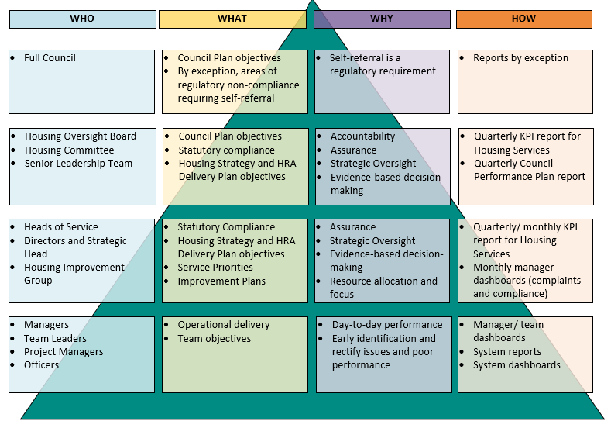
  - Diagram of pyramid approach to performance reporting

HOW WE ENSURE DATA QUALITY AND GOOD DATA GOVERNANCE
  - All performance information is underpinned by good quality data and we aim to ensure that across the service there is consistently high standard of data production and use. All staff involved in the collection, collation and reporting of performance data have a responsibility to ensure that it can be relied upon.
  - The first line of data assurance is provided by the operational function that directly owns the data. These teams and managers are responsible for ensuring robust and consistent collation of the data according to the Council’s policies and the ‘KPI dictionary’ document.
  - The Insight Officer is preparing a ‘KPI dictionary’ for each KPI and PI included within the quarterly Council Plan performance report and the quarterly/monthly Housing KPI report. This is intended to provide transparency, consistency, assurance and resilience. The KPI dictionary will set out:
    - A clear definition of the KPI
    - The system it is produced from, and any changes made to the data by the system
    - Who is the data owner
    - Any inclusions/ exclusions/ formulas that are applied to the KPI
    - Any manual amendments that are made to the data
    - Any data reconciliation or data cleansing that is required prior to generating the KPI
    - A data accuracy/ data confidence score which will be continually reviewed with the aim of improving any areas where further assurance is needed
  - The second line of assurance comes from manager and member oversight and scrutiny. These are supported by the Council’s Housing Quality Assurance Team, Asset Data Team, Information Governance Officer and Housing Insight Officer. These have responsibility for providing frameworks, guidance and tools to enable operational teams to manage their data. This second line of assurance will also provide quality assurance, monitoring and interrogation of data.
  - The third line of assurance is provided by the Internal Audit function to provide independent and objective assurance of the integrity and effectiveness of performance reporting. This will be supported by independent external consultant review of specialist areas, as well as the Regulator of Social Housing who annually reviews key performance information.

CONCLUSION
  - This Performance Reporting Framework provides an approach and a model for how the service will collect, analyse, present and use performance information. Our simple approach aims to provide the right information to the right people in order to support good governance, oversight and evidence-based decision making.
  - The Performance Reporting Framework is a live document which will be continually reviewed and updated.

